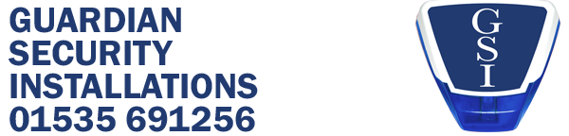

NEWSLETTER FEBRUARY 2022
We are delighted to announce that we have been celebrating 20 years in Business here at Guardian Security Installations Ltd. We would like to thank all our customers both old and new for helping us to reach this achievement. To mark this special occasion, we had a special cake made by our friend Emma Wilson. The cake was made to replicate one of our bell boxes and keypads. It looked and tasted amazing!
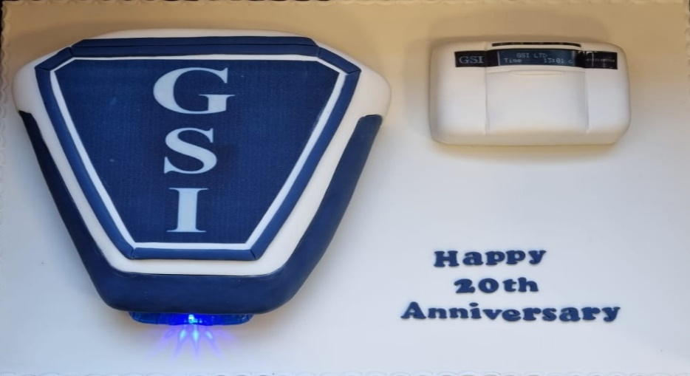
We have changed the design of ours works vehicles. The graphics were designed by Sign & Design in Keighley. We are extremely happy with the finished effect and all agree that it looks fantastic. You will spot them driving around.
